Abstract

**Professors:** Dr. Dean, Dr. Roppel

**Team Members:** Matthew Castleberry, Josh Jablonowski, Joe Hinely, Nia Perkins

**Description:** A joint project with the Student Projects and Research Committee (SPARC) to design, build, and compete an autonomous robot to collect and sort colored cubes and balls into corresponding colored corners of a small square shaped arena.

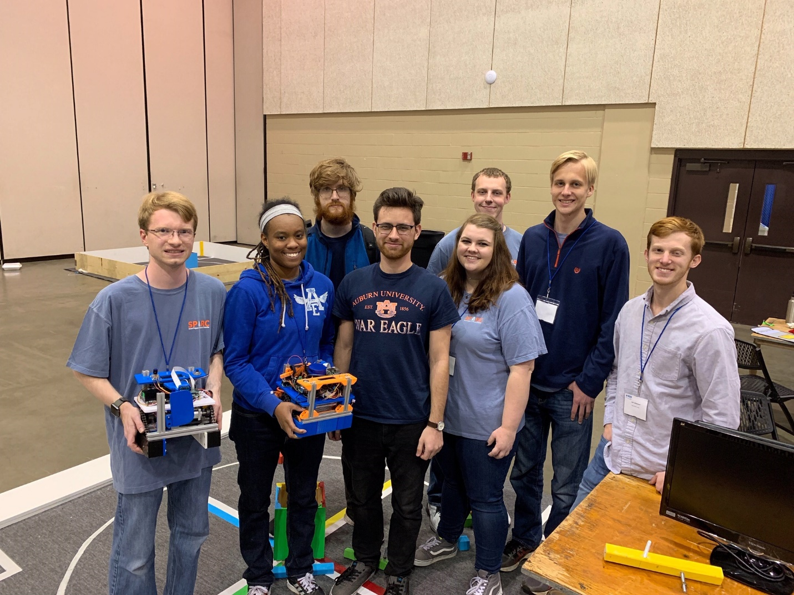

(Full Competition Team) Left to Right: Matthew Castleberry, Nia Perkins, Alex Jones, Noah Niedzwiecki, Rebecca Thomas, Joe Hinely, William Yates, Josh Jablonowski

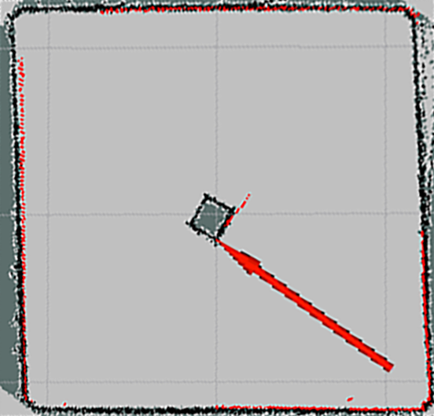 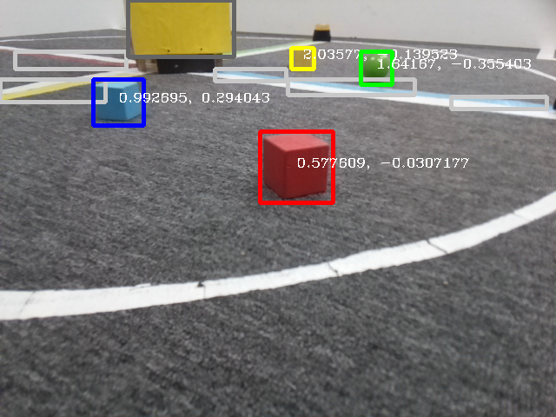

Output of image processing algorithms determining positions of objects on field with respect to robot.

Localization map indicating position and orientation of robot within arena